A Winter Visit to Ogunquit, Maine

There was a specific purpose.

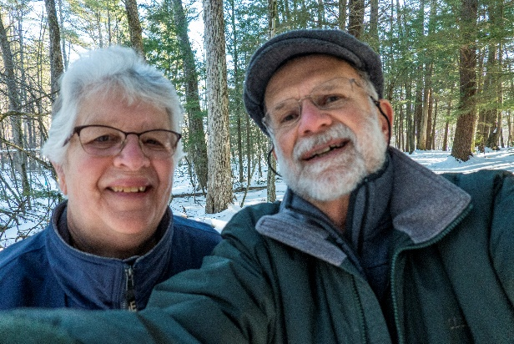We all need a mid-winter break up here. So, we headed north and stayed on the ocean at the Beachmere in Ogunquit. The weather was perfect-winter-wise with low tides in the afternoon. Perfect sunshine every day with cool moderate winds and lots of “space” as we roamed the ocean villages and the many beaches up and down the coast. The Marginal Way needed grippers to safely navigate but the street sidewalks really didn’t. For a lobster roll to die for, visit the Bistro.

The Specific purpose? 50 years ago, on February 22, he got down on his knees and proposed to her in College Woods, UNH. They re-enacted the scene on 2/22/2020 on the return trip to Keene.

As for the photos, click on the [Beachmere Inn - February, 2020](https://photos.app.goo.gl/8FhEX4QYpEhUFHzu9).